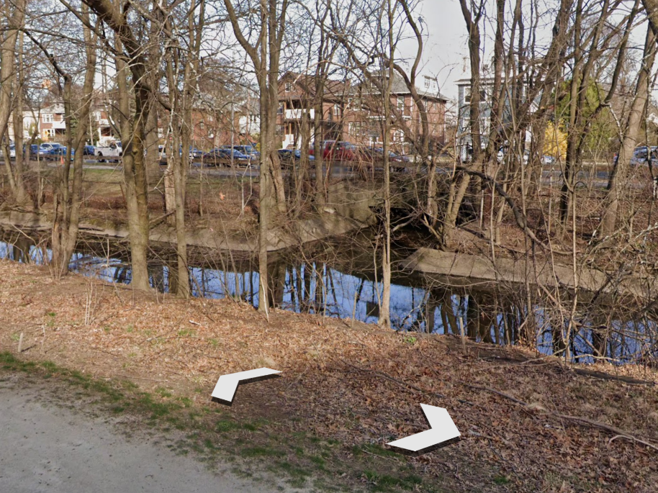

How Miyawaki Forests Can Help Solve Urban Flooding
The Boston Mycological Club lecture and a field trip
Attend one or both
Lecture: How Fungal Networks in Miyawaki Forests Can Help Solve Urban Flooding
Tuesday, July 14, 2026, at 7:00 pm
Harvard Herbaria at 22 Divinity Ave. in Cambridge

Field Trip: Miyawaki Forest and Engineering Natural Infrastructure at Alewife Brook
Saturday, July 18, 2026, at 10:00 am
Meetup: Parking lot behind the Menotomy Tavern, 25 Massachusetts Ave, Arlington
Drawing on work to propose a Miyawaki forest and nature-based stormwater infrastructure for the Alewife Brook watershed, Rob Moir will explore how fungal networks, wood-decay communities, mycorrhizae, and soil-building processes can accelerate forest establishment and reduce runoff and combined sewer overflow pollution. The talk will examine how fungi contribute to water infiltration, carbon storage, nutrient cycling, and biodiversity recovery in urban landscapes.

The Boston Mycological Club encourages Cambridge, Somerville, and MWRA to pilot Living Infrastructure as a complement to traditional engineered infrastructure. This is not an either/or proposition. Industrial infrastructure and living infrastructure perform different but complementary functions and are most effective when designed to work in concert.
Pipes, pumps, tunnels, and treatment plants convey and treat water after it enters the sewer system. Living forests, healthy soils, and the mycorrhizal networks that sustain them slow, absorb, store, and gradually release rainfall before it becomes stormwater runoff. Together, these forms of infrastructure can reduce pressure on combined sewer systems while improving water quality, ecosystem health, and climate resilience.
Mycorrhizal fungi are a foundational component of healthy forest soils. By supporting the underground networks that enhance soil structure, water infiltration, and nutrient cycling, they contribute to the natural hydrologic functions cities increasingly need as storms become more intense. We encourage pilot projects that evaluate Living Infrastructure alongside conventional engineering solutions, recognizing that resilient watersheds depend on industrial and ecological systems working in concert.

